01. Generate random values for an array

#include<stdio.h>
#include<stdlib.h>
#include<time.h>

int main() {

float a[100];
int n;
printf("Enter Number of Elements: ");
scanf("%d", &n);

srand(time(NULL));

for(int i=0; i<n; i++) {
a[i]= (float)rand()/100;
printf("a[%d] : %.2f\n", i, a[i]);
}

return 0;
}
Output:
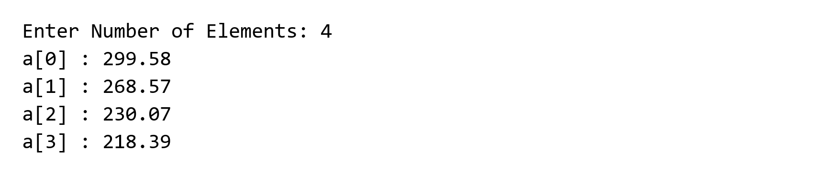
02. Count even and odd numbers in an array

#include <stdio.h>
int main(){

int arr[10] = {23, 12, 4, 7, 98, 11, 23, 46, 55, 29};

int even = 0, odd = 0;

for(int i = 0 ; i < 10; i++){
if(arr[i]%2 == 0){
even++;
}
else{
odd++;
}
}

printf("Total Even = %d | Total Odd = %d", even, odd);

return 0;
}
Output:
03. Insert an integer into an array

#include <stdio.h>
int main(){
int n = 10;
int arr[11] = {2,5,4,6,7,8,9,1,3,34};
int loc, item;

//taking input of location and item from user
printf("Enter Insert Location: ");
scanf("%d", &loc);

printf("Enter value to input: ");
scanf("%d", &item);

//shifting values to right
for(int i=n; i>loc; i--){
arr[i] = arr[i-1];
}

arr[loc] = item;

n = n+1;

//printing the final array with new item
for(int i=0; i<n; i++){
printf("%d ", arr[i]);
}

return 0;
}
Output:
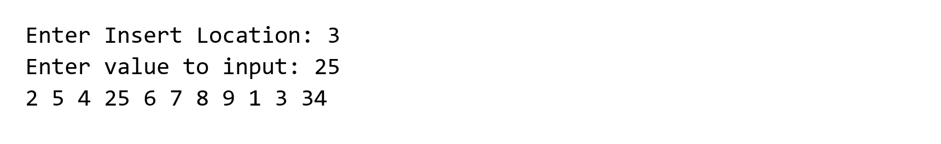
04. Delete an integer from an array

#include <stdio.h>
int main(){

int arr[10] = {5,10,15,20,30,40,50,60,70,43};
int n= 10;
int loc;

printf("Enter location to delete the item: ");
scanf("%d", &loc);

for(int i=loc; i<n-1; i++){
arr[i] = arr[i+1];
}

n = n-1;

for(int i=0; i<n; i++){
printf("%d ", arr[i]);
}

return 0;
}
Output:
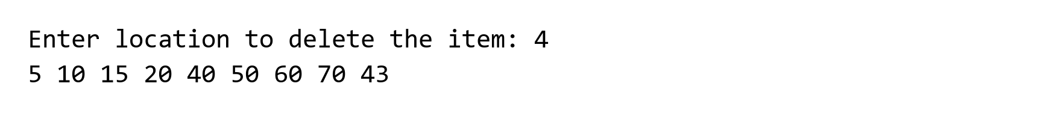
05. Insert a string into an array

#include <stdio.h>
#include <string.h>

int main() {

int n = 10;

char arr[11][20] = {
"Apple", "Banana", "Mango", "Orange", "Grape",
"Guava", "Lemon", "Papaya", "Jackfruit", "Pineapple"
};

int loc;
char item[20];

printf("Enter Insert Location: ");
scanf("%d", &loc);

printf("Enter value to input: ");
scanf("%s", item);

// Shifting
for (int i = n; i > loc; i--) {
strcpy(arr[i], arr[i - 1]);
}

// Inserting
strcpy(arr[loc], item);

n++;

// Printing
for (int i = 0; i < n; i++) {
printf("%s ", arr[i]);
}

return 0;
}
Output:
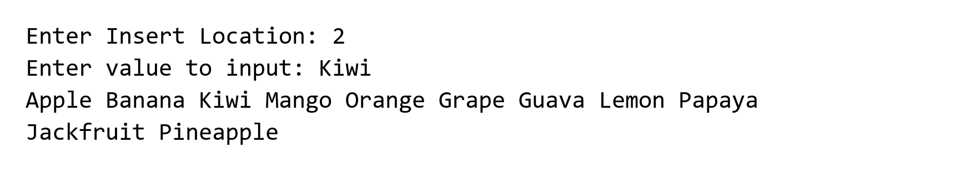
06. Delete a string from an array

#include <stdio.h>
#include<string.h>
int main(){

int n = 10;
int loc;

char str[10][20] = {
"Apple",
"Banana",
"Mango",
"Orange",
"Grape",
"Guava",
"Lemon",
"Papaya",
"Jackfruit",
"Pineapple"
};

printf("Enter Location to Delete item: ");
scanf("%d", &loc);

for(int i = loc; i < n-1; i++){
strcpy(str[i], str[i+1]);
}

n = n - 1;

for(int i = 0; i < n; i++){
printf("%s ", str[i]);
}

return 0;
}
Output:
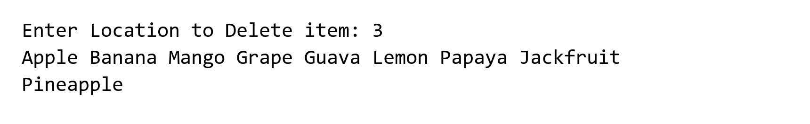
07. Find the sorted insertion index for a string

#include <stdio.h>
#include<string.h>

int main(){

char names[5][20] = {"Asif", "Farjin", "Rafit", "Sazzad", "Srabon"};

char item[20];

int index = 5;

printf("Enter Name to Push: ");
scanf("%s", item);

for(int i=0; i<5; i++){

if(strcmp(names[i], item) > 0){
index = i;
break;
}

else if(strcmp(names[i], item) == 0){
index = i+1;
break;
}

}

printf("Index : %d", index);

return 0;

}
Output:
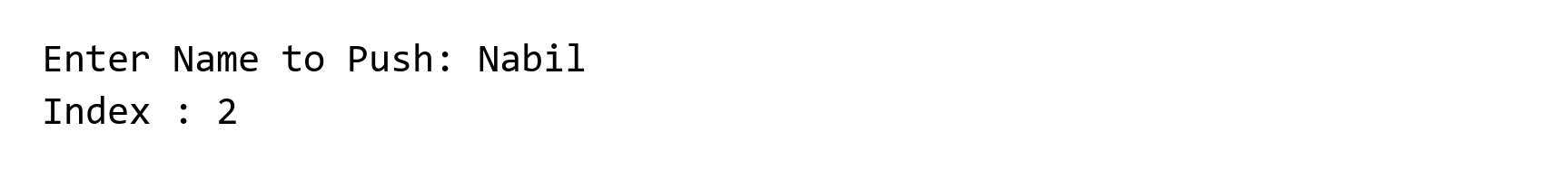
08. Search an integer using linear search

#include <stdio.h>
int main(){

int n=10;
int arr[10]={20,35,37,40,45,50,51,55,67,98};
int target;

printf("Enter target item to search: ");
scanf("%d", &target);

int flag = 0;

for(int i=0; i<n; i++){
if(arr[i] == target){
printf("Item found at index %d", i);
flag = 1;
break;
}
}

if(flag == 0){
printf("Item not found");
}

return 0;

}
Output:
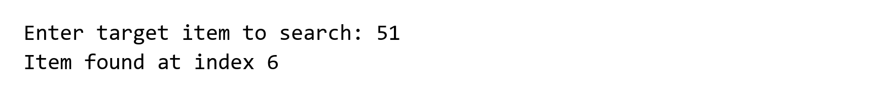
09. Search an integer using binary search

#include <stdio.h>
int main(){
int n=10;
int arr[10]={2,4,6,7,8,9,10,12,14,15};
int target = 9;
int flag = 0;

int beg = 0;
int end = n-1; // end = 9;

while(beg <= end){

int mid = (beg+end)/2;

if(arr[mid] == target){
printf("%d Found at index %d",target,mid);
flag = 1;
break;
}

else if(arr[mid] > target){
end = mid-1;
}

else beg = mid+1;
}

if(flag == 0){
printf("Target- %d Not found",target);
}

return 0;
}
Output:
10. Search strings using linear search

#include <stdio.h>
#include<string.h>

int main(){

int i, loc, n, c;
char a[100][100], item[100];

printf("Enter Number of Elements: ");
scanf("%d", &n);

printf("Enter String: \n");

for(i=1; i<=n; i++){
printf("\n[%d]= ",i);
scanf("%s", a[i]);
}

while(1){

loc = -1;

printf("Enter Searching Item: ");
scanf("%s", item);

for(i=1; i<=n; i++){
if(strcmp(item, a[i]) == 0){
loc = i;
break;
}
}

if(loc == -1){
printf("\nAbsent");
}
else
printf("\nPresent at Location: %d", loc);

printf("\nEnter 1 for search again, any number for exit: \n");
scanf("%d", &c);

if(c != 1){
return 0;
}

}

return 0;

}
Output:
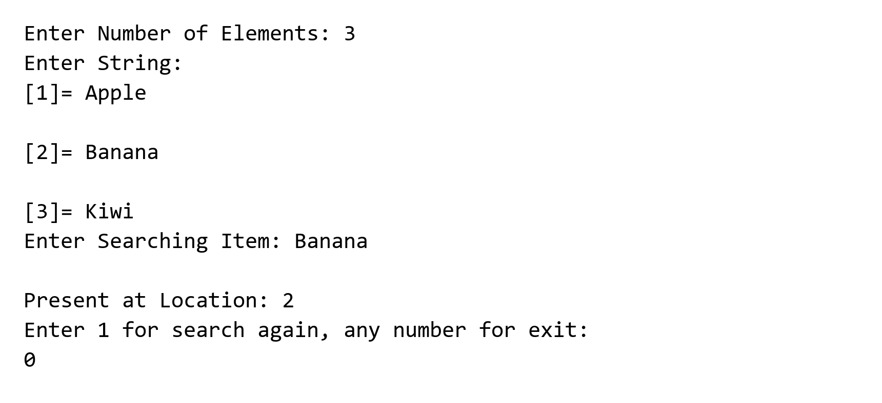
11. Search a string using binary search

#include <stdio.h>
#include<string.h>

int main(){
char arr[10][20] = {
"Apple",
"Banana",
"Grape",
"Guava",
"Jackfruit",
"Lemon",
"Mango",
"Orange",
"Papaya",
"Pineapple"
};

char target[10] = {"Lemon"};

int beg = 0, end = 10-1;
int flag = 0;

while(beg <= end){
int mid = (beg + end)/2;

if(strcmp(arr[mid], target) == 0){
printf("%s found at index %d", target, mid);
flag = 1;
break;
}

else if(strcmp(arr[mid], target) > 0){
end = mid - 1;
}

else if(strcmp(arr[mid], target) < 0){
beg = mid + 1;
}
}

if(flag == 0){
printf("%s not found ! ", target);
}

return 0;
}
Output:
12. Sort integers using bubble sort

#include <stdio.h>
#include<stdlib.h>
#include<time.h>

int main(){
int a[50];
int n,temp;

printf("Enter Number of elements :");
scanf("%d", &n);

srand(time(NULL));
for(int i=0; i<n; i++){
a[i] = rand()/100;
printf("%d\n", a[i]);
}

for(int j=1; j<=n-1; j++){
printf("\nPass %d:\n", j);

for(int i=0;i<n-j; i++ ){
if(a[i]>a[i+1]){
temp = a[i];
a[i] = a[i+1];
a[i+1] = temp;
}
for(int k=0;k<n; k++){
printf("%5d",a[k]);
}
printf("\n");

}
}

printf("\n\nSorted list :");
for(int i=0; i<n; i++){
printf("\na[%d] = %d", i,a[i]);

}
return 0;
}
Output:
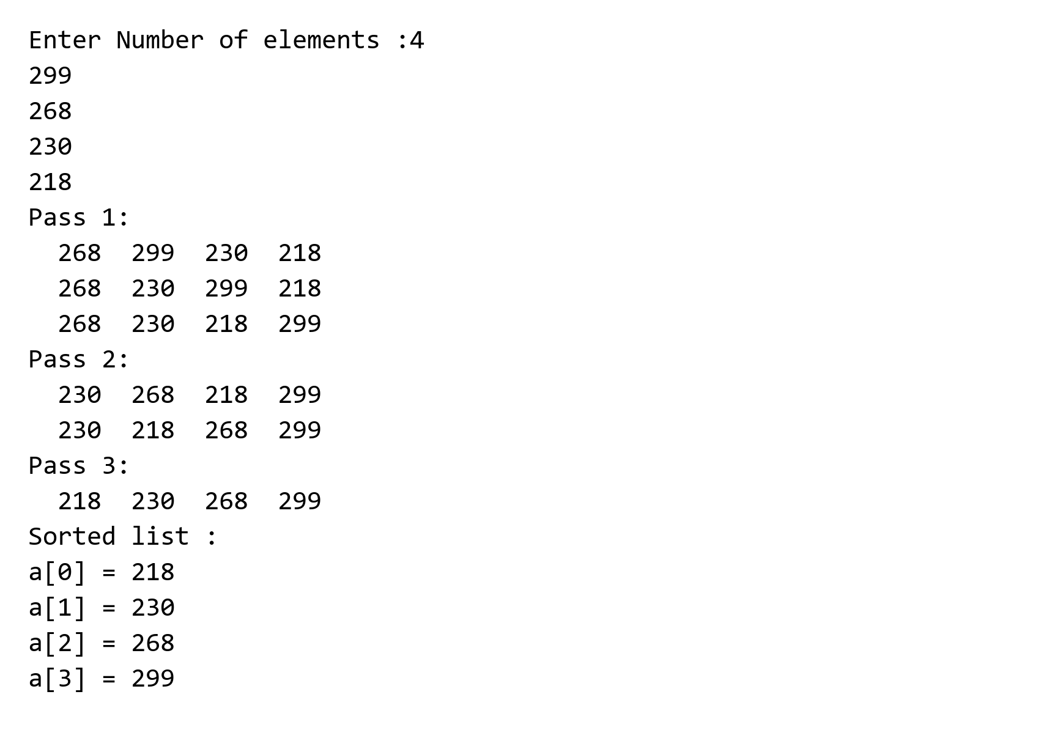
13. Sort strings using bubble sort

#include <stdio.h>
#include <string.h>

int main(){

char a[10][20] = {
"Mango",
"Apple",
"Orange",
"Banana",
"Grape",
"Lemon",
"Guava",
"Papaya",
"Jackfruit",
"Pineapple"
};

int n = 10;
char temp[20];

// Bubble Sort
for(int j = 1; j <= n - 1; j++){

printf("\nPass %d:\n", j);

for(int i = 0; i < n - j; i++){

if(strcmp(a[i], a[i + 1]) > 0){

strcpy(temp, a[i]);
strcpy(a[i], a[i + 1]);
strcpy(a[i + 1], temp);
}

// Printing array after each comparison
for(int k = 0; k < n; k++){
printf("%15s", a[k]);
}

printf("\n");
}
}

printf("\n\nSorted list:");

for(int i = 0; i < n; i++){
printf("\na[%d] = %s", i, a[i]);
}

return 0;
}
Output:
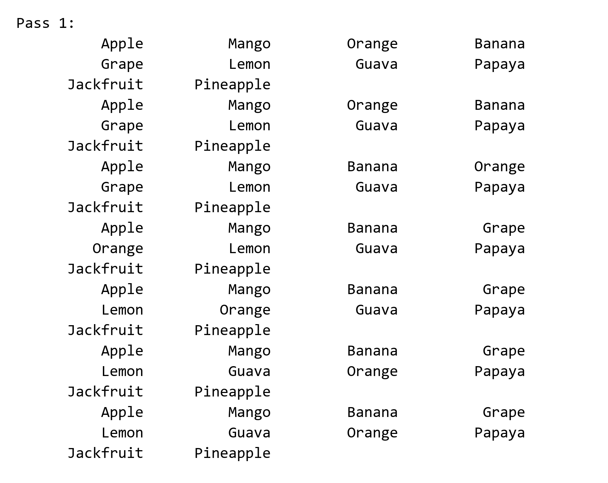
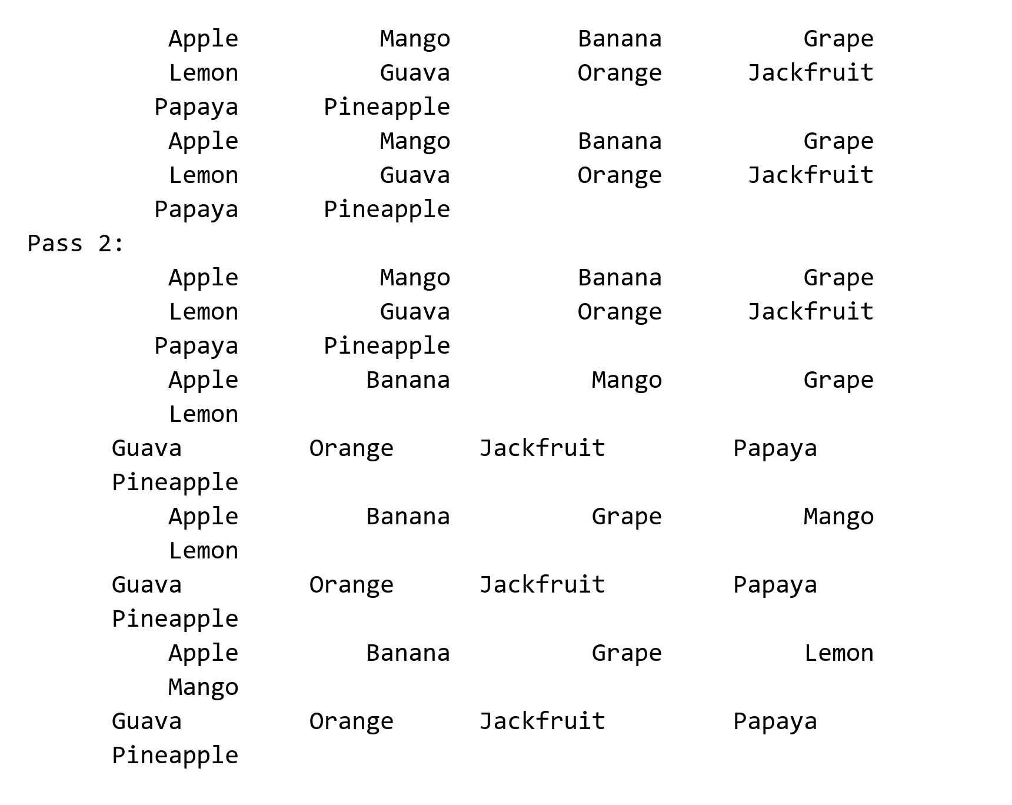
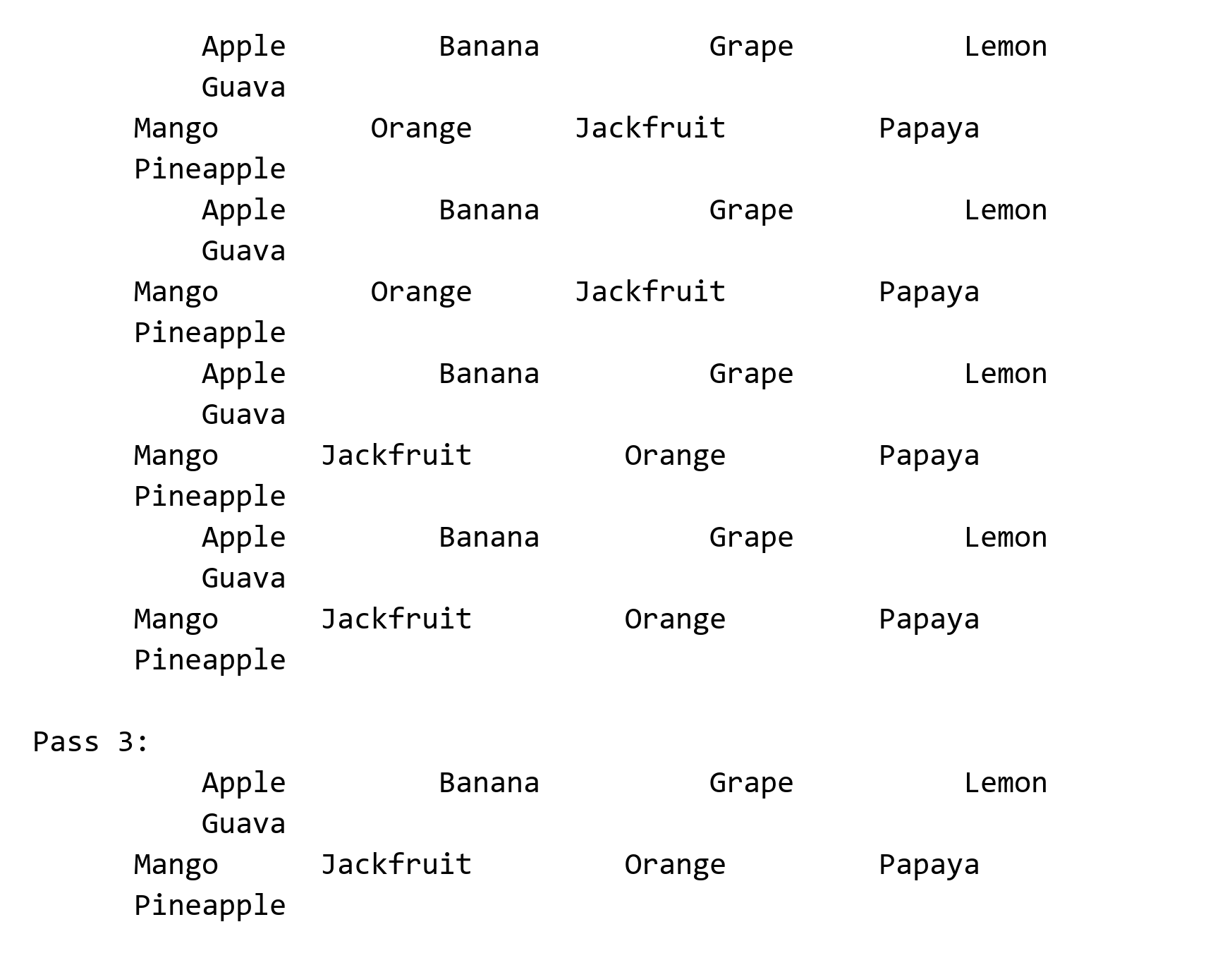
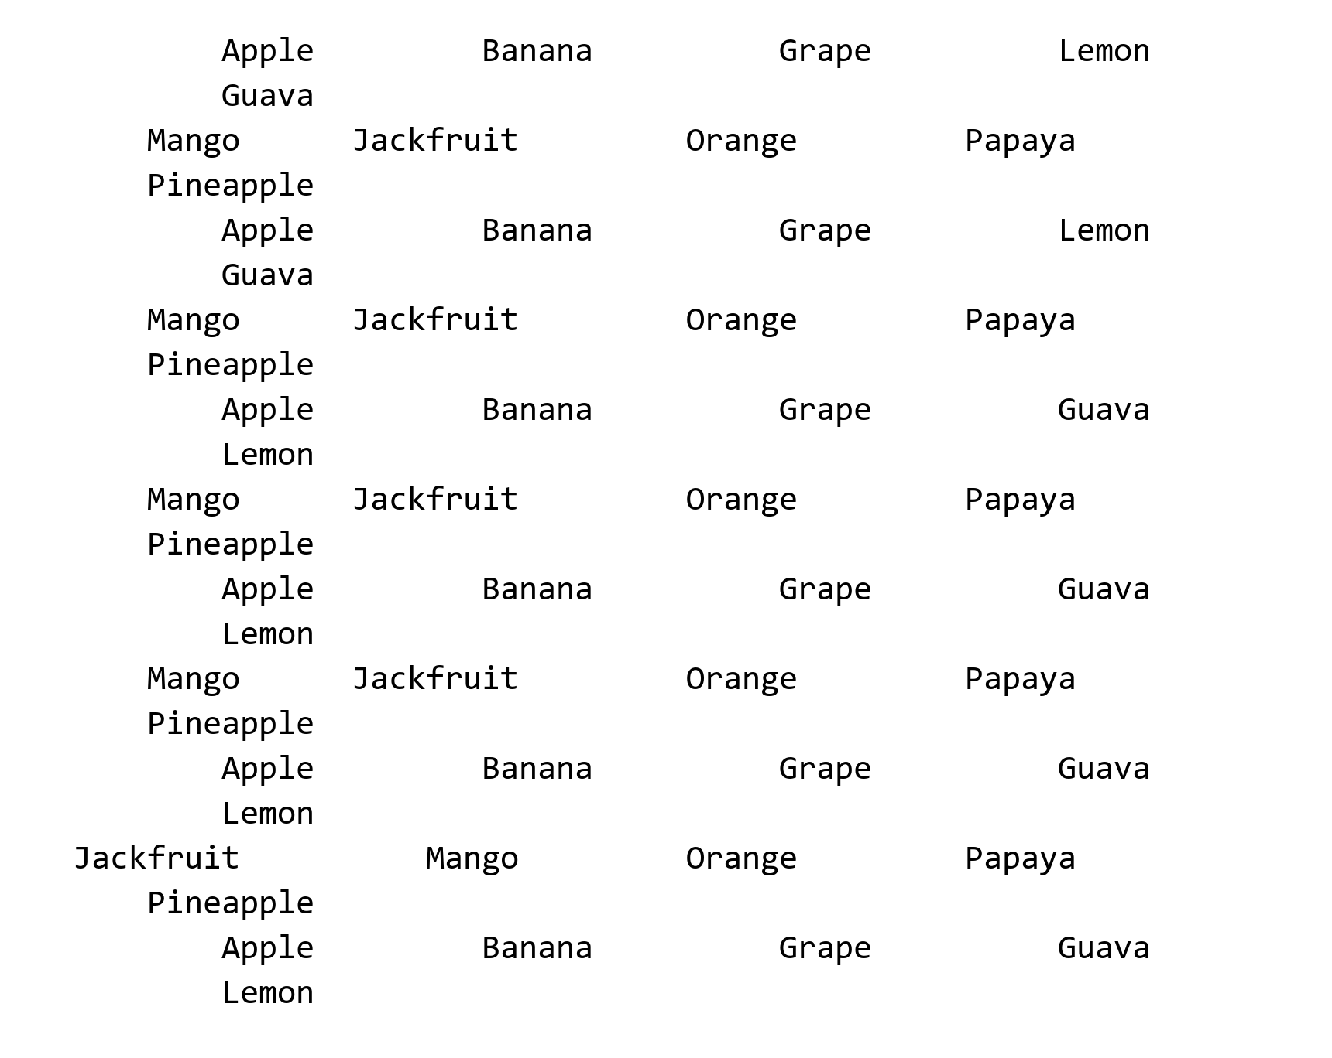
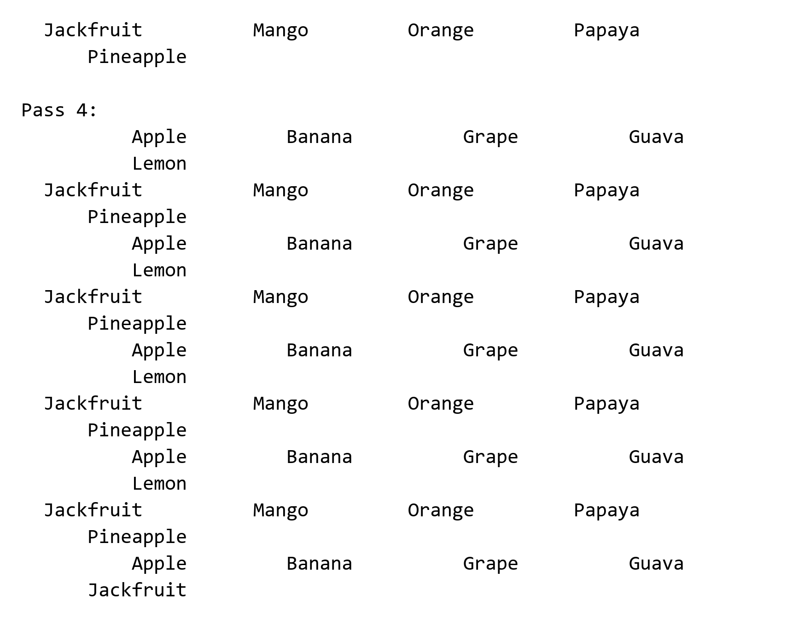
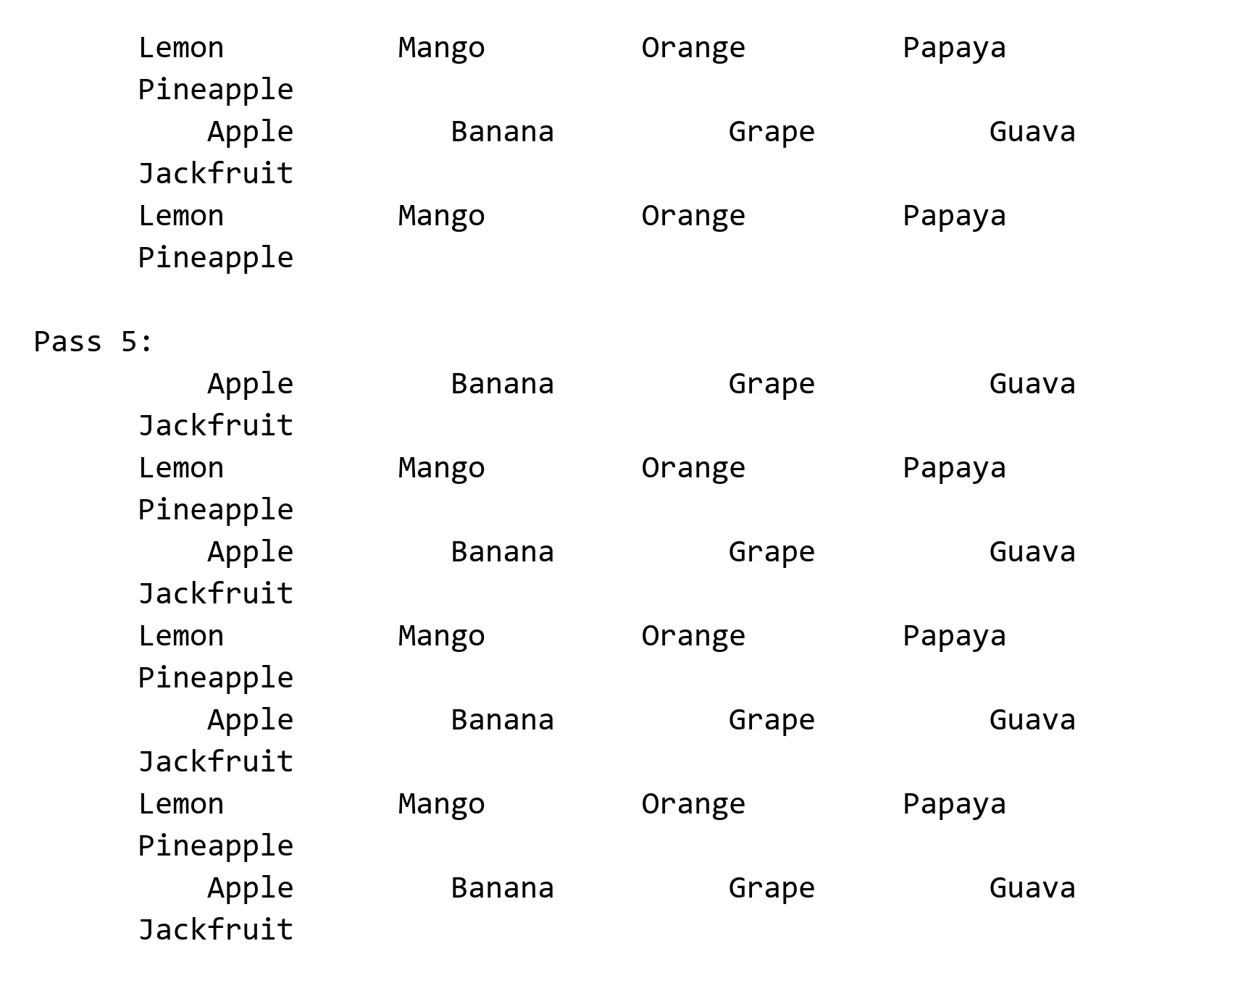
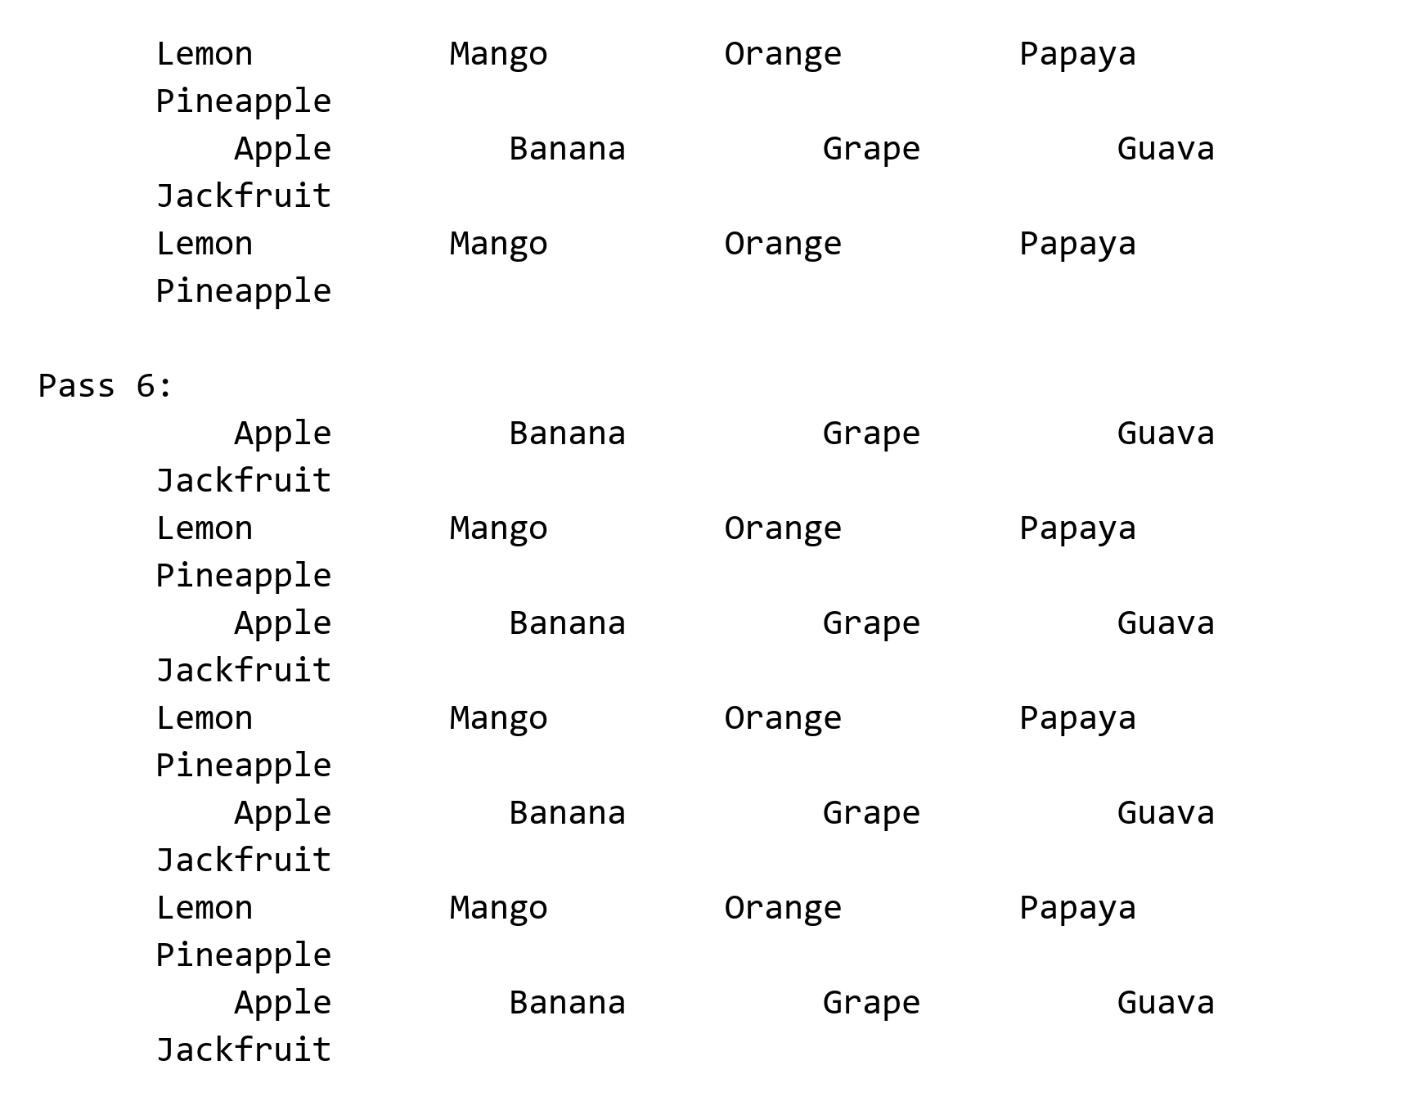
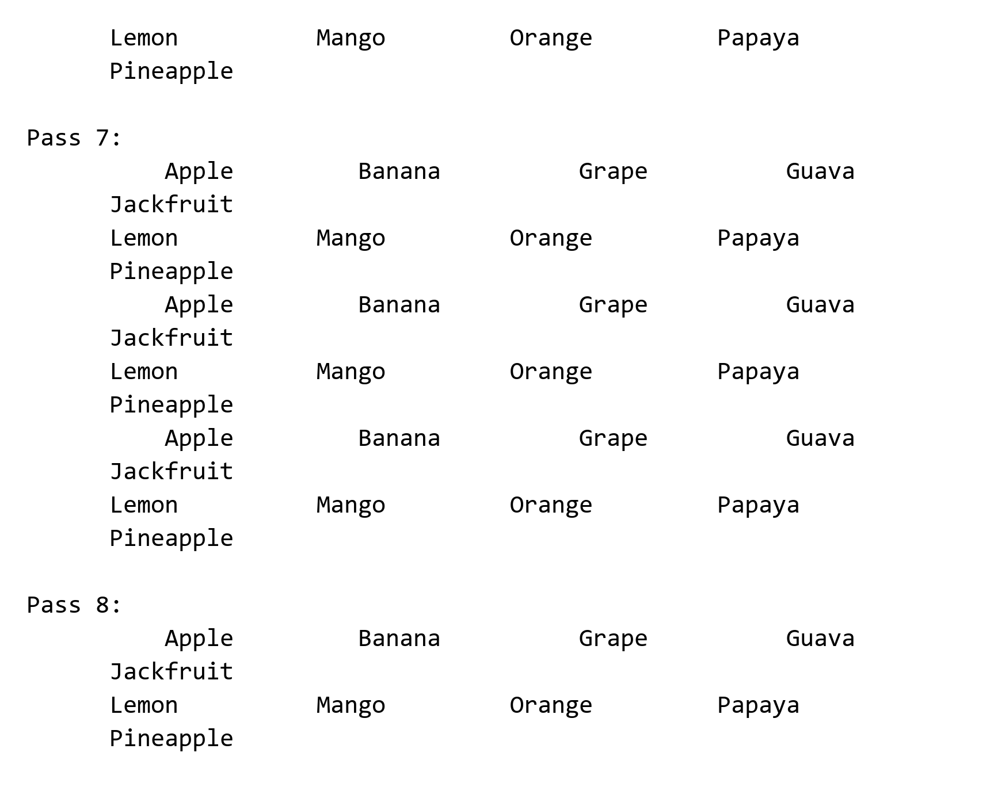
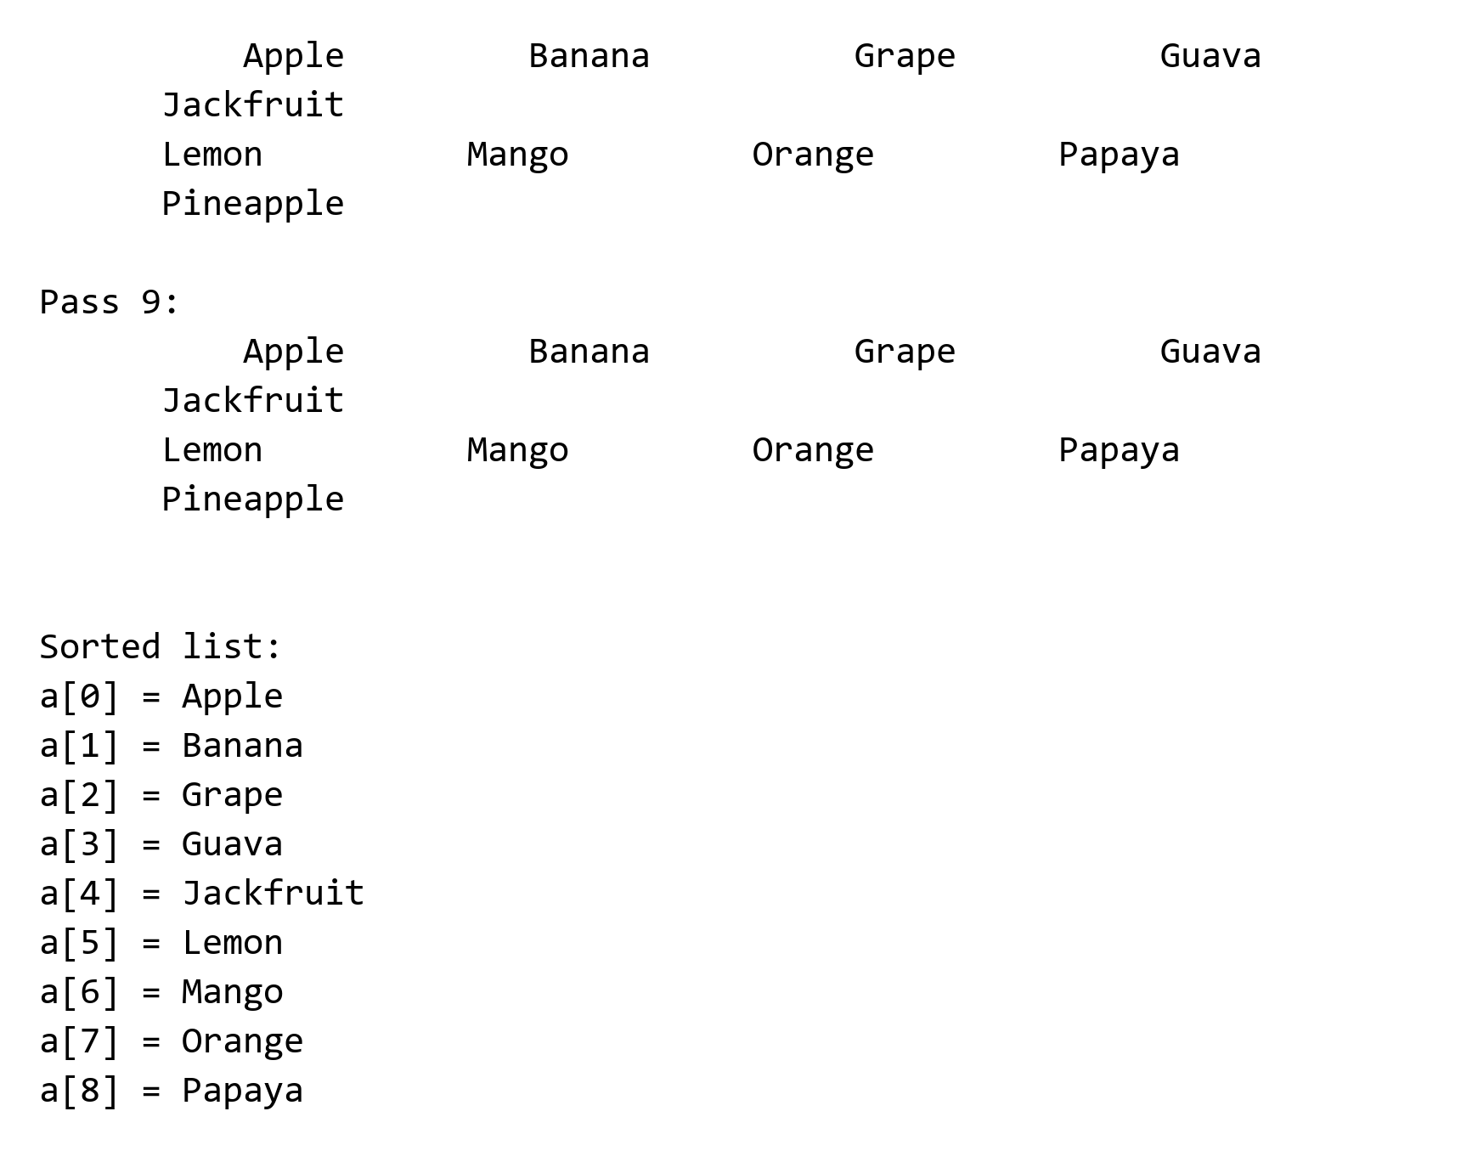
14. Sort values read from a text file

#include <stdio.h>
int main(){
int n=10, temp;
int arr[10];

FILE *myfile;
myfile = fopen("unsorted_ value.txt", "r");

for(int i=0; i<n; i++){
fscanf(myfile, "%d", &arr[i]);
}
fclose(myfile);

printf("Unsorte value from file :\n");
for(int i=0; i<n; i++){
printf("%d ",arr[i]);
}

for(int i=1; i<n; i++){
for(int j=0; j<n-i; j++){

if(arr[j] > arr[j+1]){
temp = arr[j];
arr[j] = arr[j+1];
arr[j+1] = temp;
}
}
}

printf("\nSorted value :\n");
for(int i=0; i<n; i++){
printf("%d ",arr[i]);
}

myfile = fopen("sorted_value.txt", "w");

for(int i=0; i<n; i++){
fprintf(myfile, "%d ", arr[i]);
}

fclose(myfile);

return 0;
}
Output:
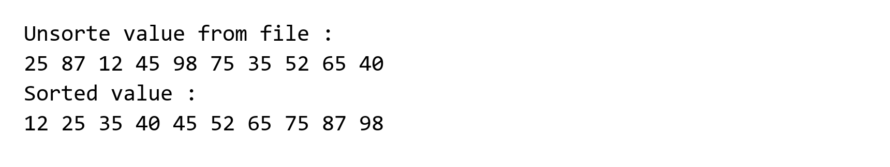
15. Push items onto a stack
#include <stdio.h>
#include<stdlib.h>

int stk[5], max = 5, item;

int top = -1;

void push(){
if(top == max-1){
printf("Stack is Full");
exit(0);
}else{

top++;

stk[top] = item;

for(int i=top; i>=0; i--){
printf("stk[%d] = %d\n", i, stk[i]);
}
}
}

int main(){

while(1){

printf("\nEnter Item to push: ");
scanf("%d", &item);

push();

}

return 0;
}
Output:
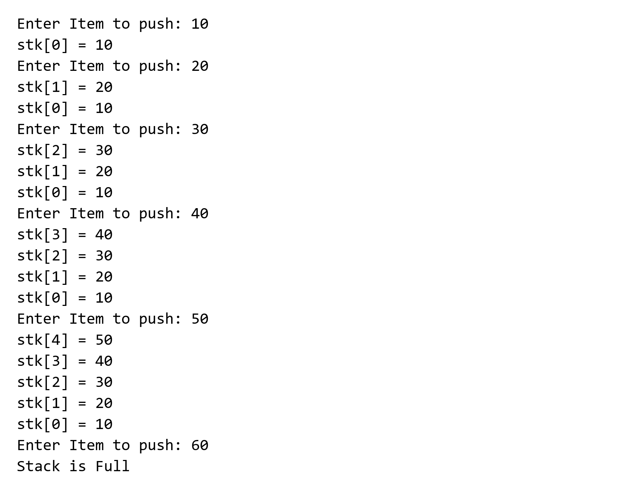
16. Perform push and pop operations using a stack

#include<stdio.h>

int stk[20], i, mx = 5, top= -1, item, c;

int pop(){
if(top == -1){
printf("Stack is empty/underflow");
return 0;
}

item = stk[top];
top = top - 1;

printf("\nPopped item = %d", item);
printf("\nSTACK: \n");

for(i = top; i>=0; i--){
printf("\nstack[%d]= %d", i, stk[i]);
}

return 0;
}

int push(){
if(top == mx-1){
printf("\nStack is full/overflow");
return 0;
}

top = top+1;
printf("\nEnter new item to push: ");
scanf("%d", &item);
stk[top] = item;
printf("\nSTACK: \n");

for(i=top; i>=0; i--){
printf("\nstack[%d]= %d", i, stk[i]);
}

return 0;
}

int main(){
for( ; ; ){
printf("\nEnter your choice:\n 1. PUSH\n 2. POP\n 3. EXIT\n");
scanf("%d", &c);

switch(c){
case 1: push();
break;

case 2: pop();
break;

default:
return 0;
}
}

return 0;
}
Output:
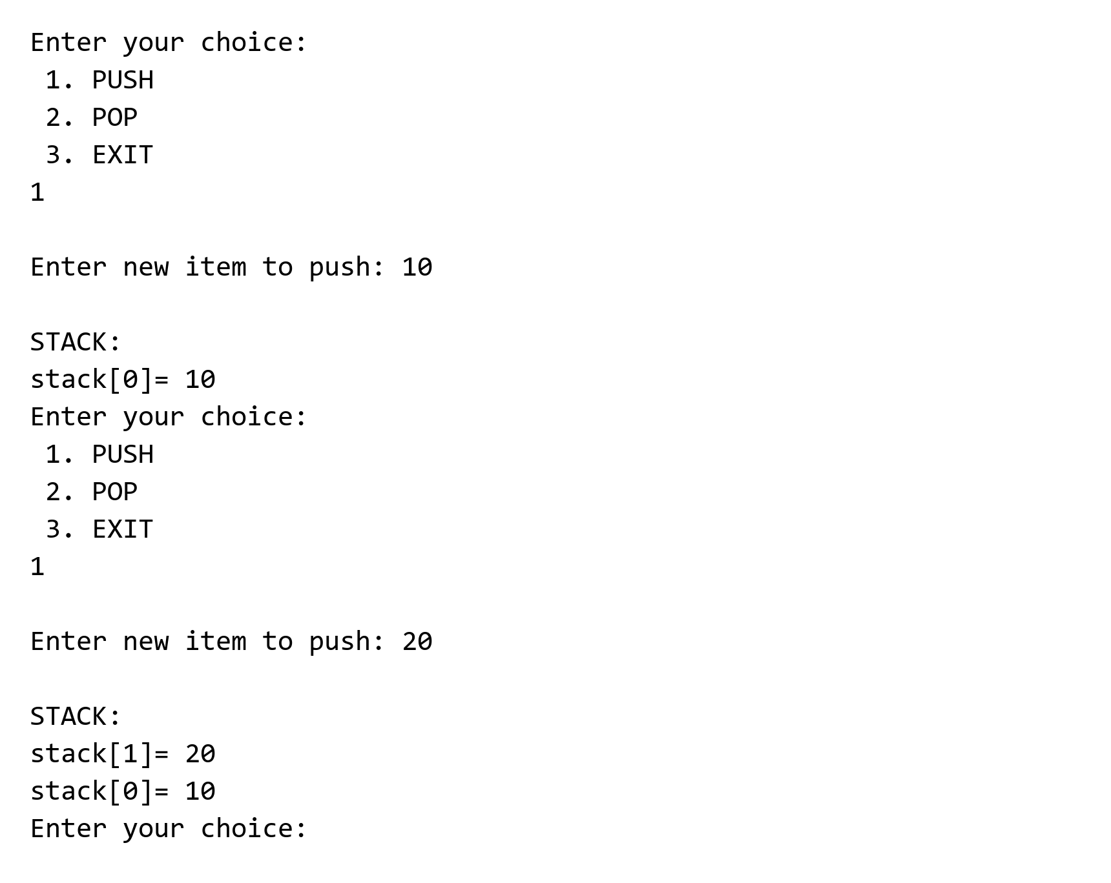
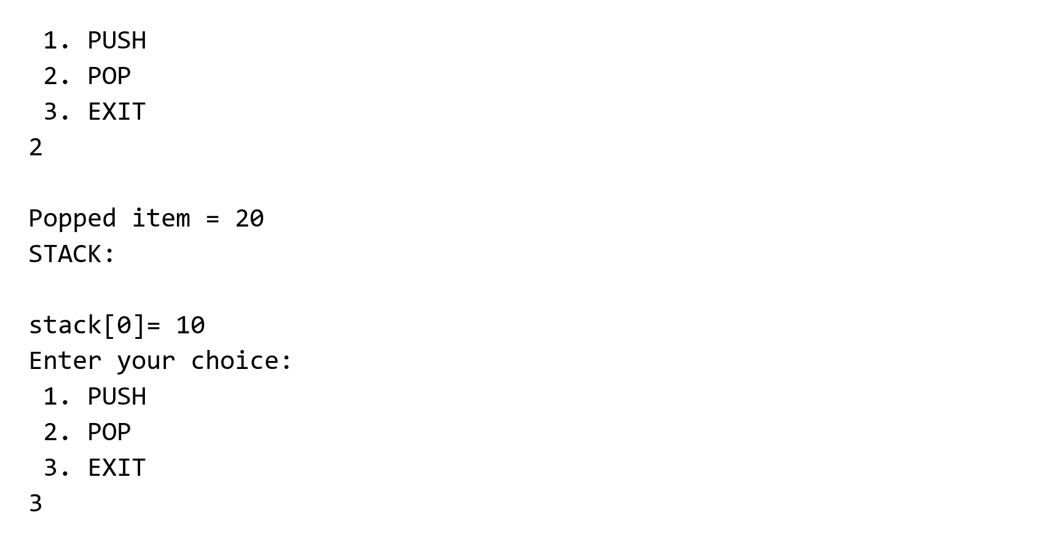
17. Perform enqueue and dequeue operations on a queue
#include <stdio.h>

int queue[20], n = 5;
int front = -1, rear = -1;

void enqueue(int x)
{
if(rear == n-1)
{
printf("Queue is full");
return;
}

else if(front == -1 && rear == -1)
{
front = rear = 0;
queue[rear] = x;
}

else{
rear++;
queue[rear] = x;
}

for(int i = front; i<=rear; i++){
printf("queue[%d]= %d\n", i, queue[i]);
}
}

void dequeue()
{
if(front == -1 && rear == -1)
{
printf("Queue is empty");
return;
}

else if(front == rear)
{
printf("Deleted item = %d\n", queue[front]);
front = -1;
rear = -1;
}
else
{
printf("Deleted item = %d\n", queue[front]);

front++;
}

if(front != -1)
{
for(int i = front; i <= rear; i++){
printf("queue[%d] = %d\n", i, queue[i]);
}
}
}

int main()
{
int choice, x;

while(1)
{
printf("\n\n1. Enqueue");
printf("\n2. Dequeue");
printf("\n3. Exit");
printf("\nEnter choice: ");
scanf("%d", &choice);

switch(choice)
{
case 1:
printf("Enter item: ");
scanf("%d", &x);
enqueue(x);
break;

case 2:
dequeue();
break;

case 3:
return 0;

default:
printf("Invalid choice");
}
}

return 0;
}
Output:
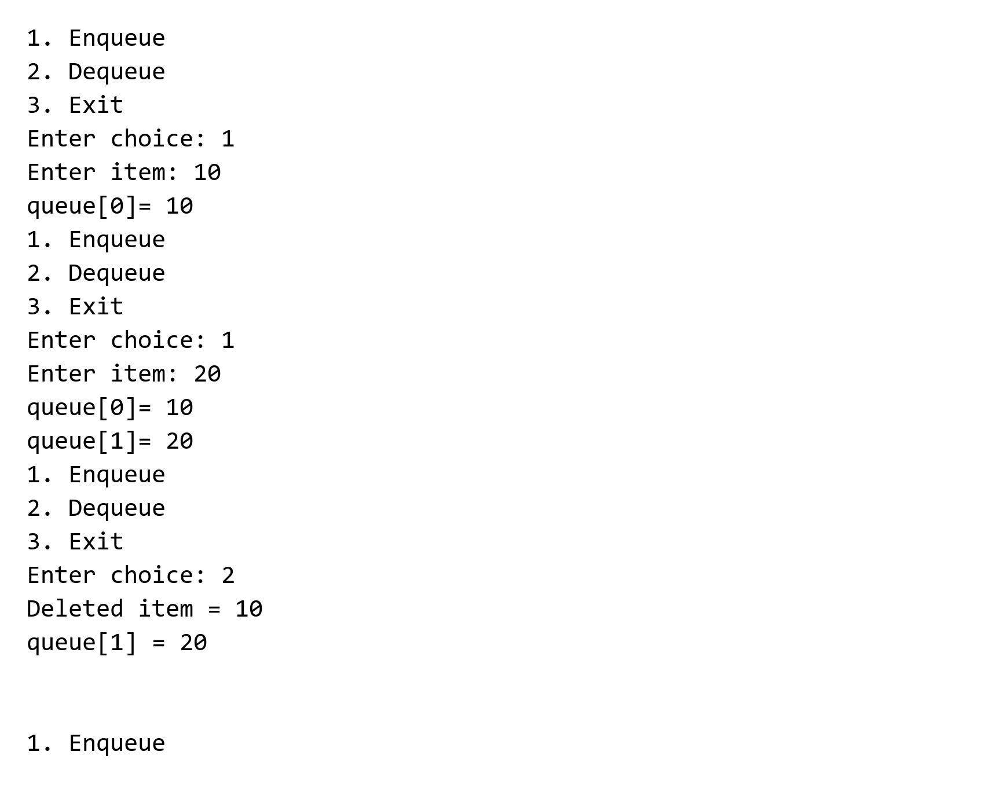
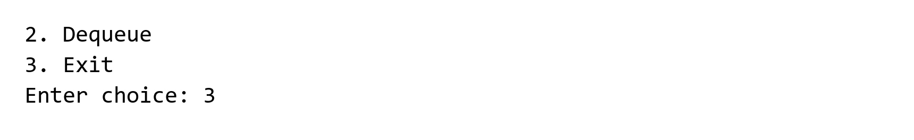
18. Insert and delete items in a circular queue

#include <stdio.h>
#include<stdlib.h>

int i, max=5, f=0, r=0, item,c;
int cQ[10] = {0,0,0,0,0,0,0,0,0,0};

int qdel() {

if(f==0 && r==0){
printf("\nQueue is empty");
return 0;
}
cQ[f] = 0;

if(f==r){
f=0;
r=0;
}

else if(f == max){
f = 1;
}else{
f= f+1;
}

system("cls");
printf("\n\tQUEUE: \n");
printf("\n\tFRONT = %d", f);
printf("\n\tREAR = %d\n", r);

for(i=1; i<=max; i++){
printf("%5d", cQ[i]);
}
}

int qins() {
if( (f == 1 && r == max) || (f == r+1)){
printf("Queue is Full");
return 0;
}

if(f==0 && r==0){
f=1;
r=1;
}

else if(r==max){
r=1;
}else{
r=r+1;
}

printf("\n\tEnter new item for Insert: ");
scanf("%d", &item);
cQ[r] = item;

system("cls");
printf("\n\tQueue: \n");
printf("\n\tFRONT = %d", f);
printf("\n\tREAR = %d\n", r);

for(int i=1; i<=max; i++){
printf("%5d", cQ[i]);
}
}

int main(){

for( ; ; ){
printf("\nEnter your choice: \n\t1. QINSERT\n\t2. QDELETE\n\t3. Exit\n");
scanf("%d", &c);

switch(c) {
case 1:
qins();
break;

case 2:
qdel();
break;

default:
return 0;
}
}

return 0;
}
Output:
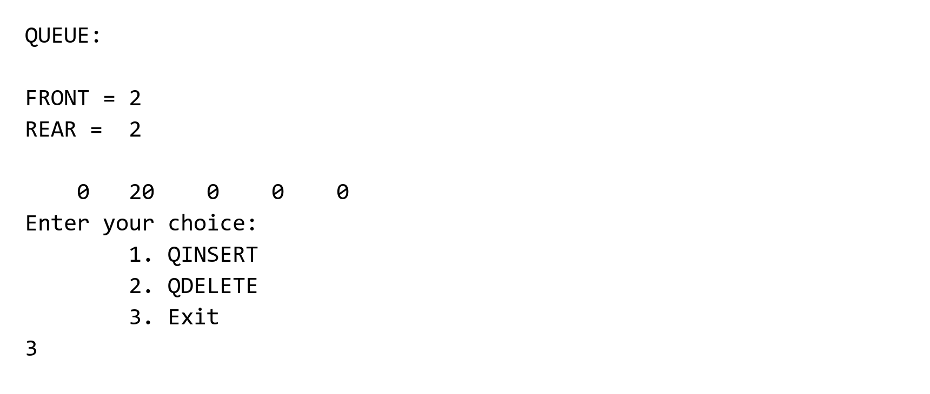
19. Perform enqueue and dequeue operations on a circular queue
#include <stdio.h>

int queue[20], N = 5;
int front = -1, rear = -1;

void enqueue(int x)
{
if((rear + 1) % N == front)
{
printf("Queue is full/Overflow");
return;
}

else if(front == -1 && rear == -1)
{
front = rear = 0;
queue[rear] = x;
}

else
{
rear = (rear + 1) % N;
queue[rear] = x;
}

printf("\nQueue:\n");

int i = front;

while(1)
{
printf("queue[%d] = %d\n", i, queue[i]);

if(i == rear)
break;

i = (i + 1) % N;
}
}

void dequeue()
{
if(front == -1 && rear == -1)
{
printf("Queue is empty/Underflow");
return;
}

else if(front == rear)
{
printf("Deleted item = %d\n", queue[front]);

front = rear = -1;
}

else
{
printf("Deleted item = %d\n", queue[front]);

front = (front + 1) % N;
}

if(front != -1)
{
printf("\nQueue:\n");

int i = front;

while(1)
{
printf("queue[%d] = %d\n", i, queue[i]);

if(i == rear)
break;

i = (i + 1) % N;
}
}
}

int main()
{
int choice, x;

while(1)
{
printf("\n\n1. Enqueue");
printf("\n2. Dequeue");
printf("\n3. Exit");
printf("\nEnter choice: ");
scanf("%d", &choice);

switch(choice)
{
case 1:
printf("Enter item: ");
scanf("%d", &x);
enqueue(x);
break;

case 2:
dequeue();
break;

case 3:
return 0;

default:
printf("Invalid choice");
}
}

return 0;
}
Output:
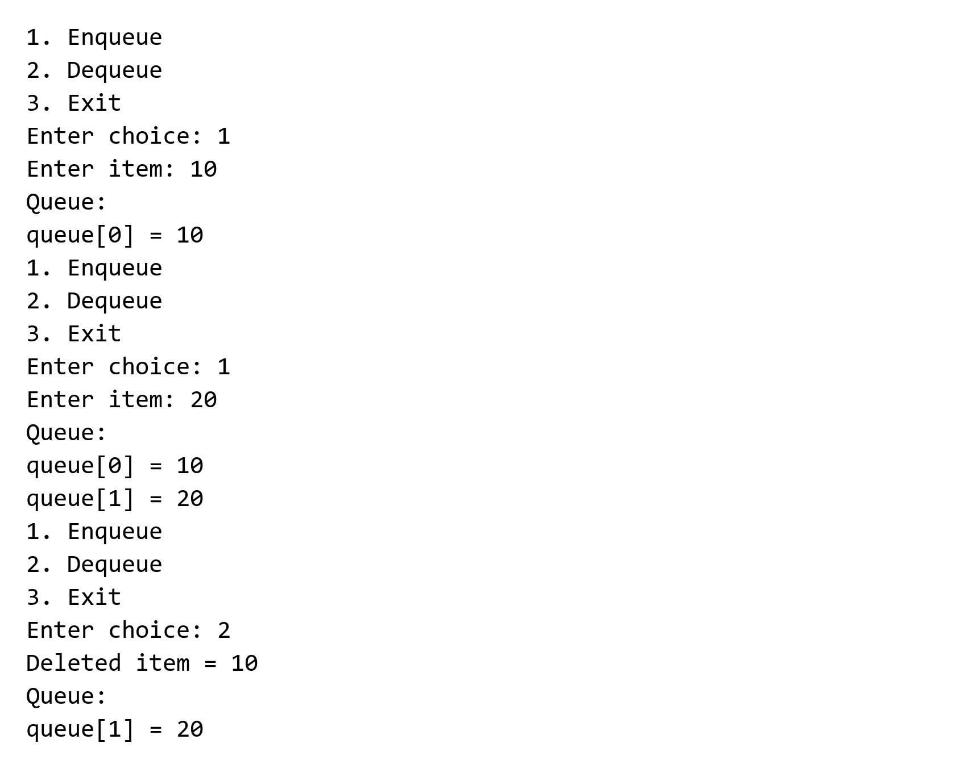
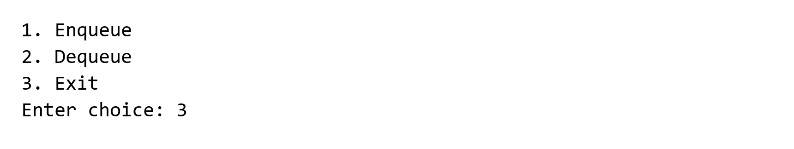
20. Create and display a linked list
#include <stdio.h>
#include <stdlib.h>

// 1. Define the structure of a node
struct Node {
int data;
struct Node* next;
};

int main() {
int n, i, value;
struct Node *head = NULL, *temp = NULL, *newNode = NULL;

printf("Enter the number of elements (n): ");
scanf("%d", &n);

if (n <= 0) {
printf("List size must be greater than 0.\n");
return 0;
}

// 2. Loop to create 'n' elements dynamically
for (i = 1; i <= n; i++) {
printf("Enter data for element %d: ", i);
scanf("%d", &value);

// Allocate memory for the new node
newNode = (struct Node*)malloc(sizeof(struct Node));
newNode->data = value;
newNode->next = NULL;

if (head == NULL) {
// If the list is empty, make this the first (head) node
head = newNode;
temp = head;
} else {
// Otherwise, link the previous node to this new node
temp->next = newNode;
temp = newNode; // Move the temp tracker to the new end node
}
}

// 3. Traverse and display the linked list
printf("\nCreated Linked List: ");
temp = head;
while (temp != NULL) {
printf("%d -> ", temp->data);
temp = temp->next;
}
printf("NULL\n");

// 4. Free allocated memory (Good practice)
temp = head;
while (temp != NULL) {
struct Node* nextNode = temp->next;
free(temp);
temp = nextNode;
}

return 0;
}
Output:
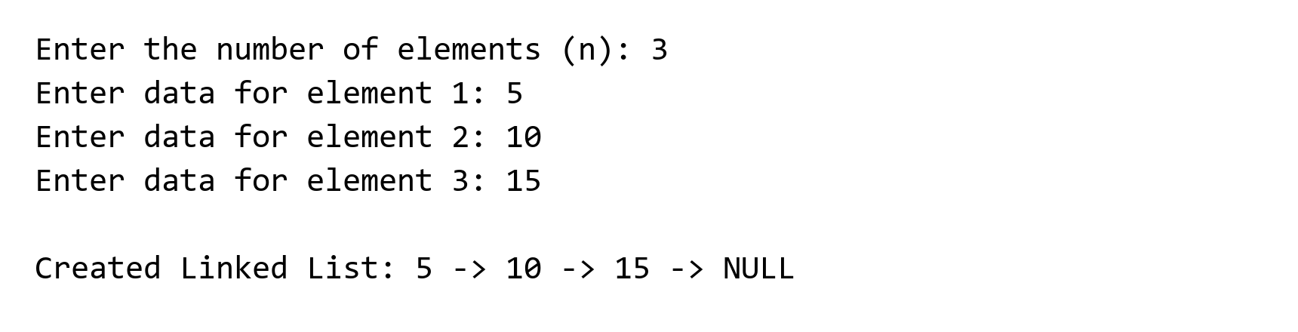
21. Solve the Tower of Hanoi using recursion

#include <stdio.h>

int n;

void Tower(int n, char bg, char ax, char ed){
if(n == 1){
printf("\n%c ----> %c", bg, ed);
}
else{
Tower(n-1, bg, ed, ax);
printf("\n%c ----> %c", bg, ed);
Tower(n-1, ax, bg, ed);
}
}

int main(){

printf("\nEnter Number of Disks: ");
scanf("%d", &n);
Tower(n, 'a', 'b', 'c');

return 0;
}
Output:
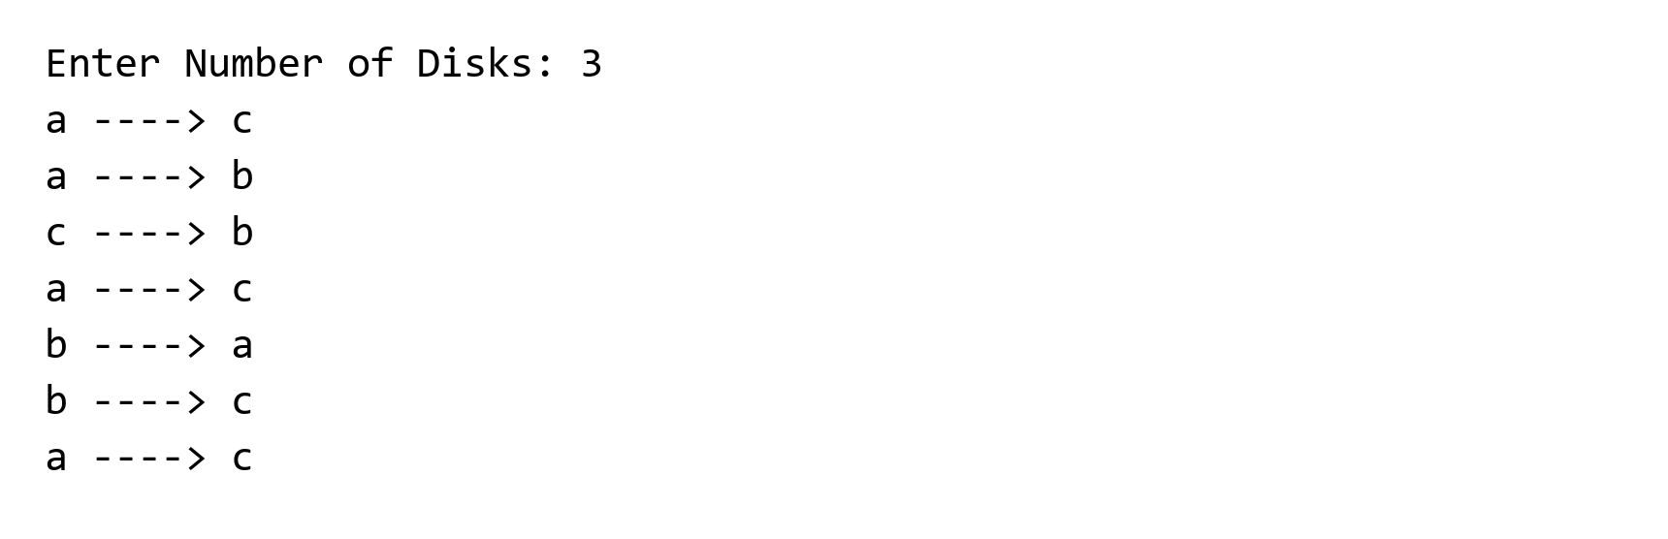
22. Read values from a text file and write them to another file

#include <stdio.h>
int main(){

int n;
printf("Enter number of values to take input: ");
scanf("%d", &n);

FILE *fp;

int arr[10];

fp = fopen("input-from-text-file.txt", "r");

for(int i=0; i<n ; i++){
fscanf(fp, "%d", &arr[i]);
printf("%d ", arr[i]);
}

fclose(fp);

fp = fopen("display-output-file.txt", "w");

for(int i=0; i<n; i++){
fprintf(fp, "%d ", arr[i]);
}

fclose(fp);

return 0;
}
Output:
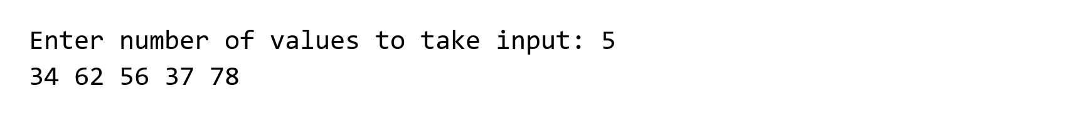
23. Store and display student information using a file
#include <stdio.h>
int main(){

typedef struct{ // struct is user defined data type

char name[50];
int roll;
float cgpa;
}student;

int n;

FILE *fp;

fp = fopen("student-info.txt", "w");

printf("Enter Number of Student: ");
scanf("%d", &n);

student std[n];

for(int i =0; i<n; i++){

printf("Enter info of Student: %d\n", i+1);

printf("Name: ");
scanf(" %[^\n]", std[i].name);

printf("Roll: ");
scanf("%d", &std[i].roll);

printf("CGPA: ");
scanf("%f", &std[i].cgpa);
}

for(int i=0; i<n; i++){
fprintf(fp, "\nName: %s \nRoll: %d CGPA: %.2f\n", std[i].name, std[i].roll, std[i].cgpa);
}

fclose(fp);

fp = fopen("student-info.txt", "r");

char ch;

while((ch = fgetc(fp)) != EOF){
printf("%c", ch);
}

fclose(fp);

return 0;
}
Output:
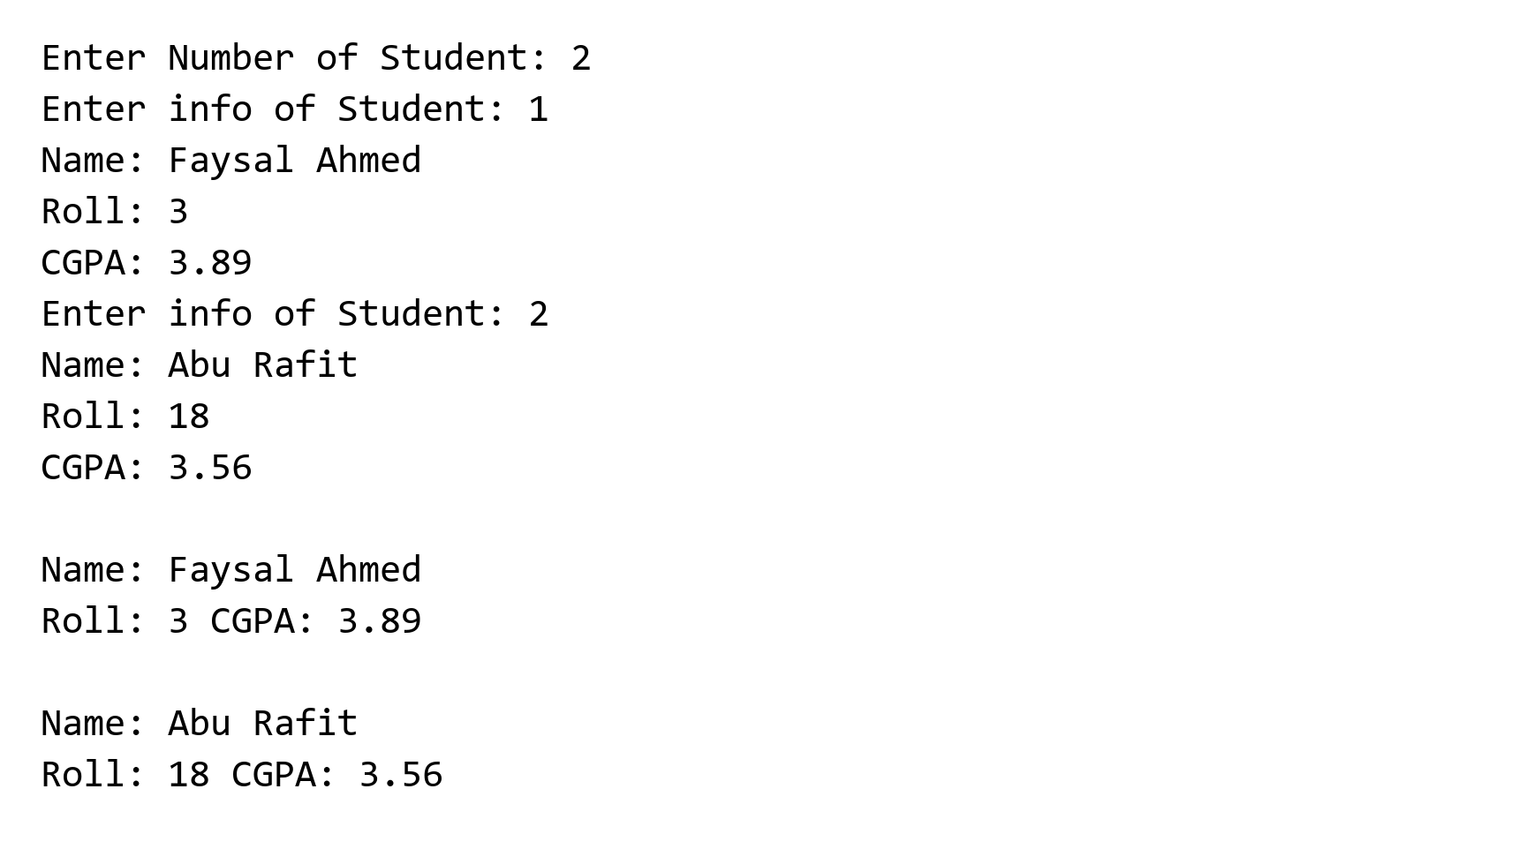
24. Empty editor placeholder
tempCodeRunnerFile.c is empty (2 bytes) and contains no executable program.

